FROM BULGARIA:
Dear brothers and sisters!
The pandemic has presented us with new and great challenges, but our God is great and He deserves to be served. I will briefly share news from the last 6 months that our ministers have sent in. Let’s thank God together and pray that He will help us to be faithful in our calling!
We wish all of you to experience God's blessings in this difficult time!
Rev. Georgi Zhelev
Chairman of UECC - Bulgaria

Thank God so far no member of the church has died from the virus.
Quite a lot of people in our church have had the virus, even myself. I was very ill and thank God I survived. This year there was an initiative in our church and money from a donation to make 1000 brochures and to evangelize the people of our city. There were no brochures left, we are even thinking of doing more. Due to the restrictions because of Covid 19 we have currently restricted visits to the nursing home, which is located near the city and are praying to have a person to take over this ministry.
Rev. Veselin Krastev - ECC - Dupnitsa

Past year, the church in Pazardzhik had its spiritual life. In a pandemic situation, Sunday services were not interrupted, as well as the Bible studies and prayer meetings. The church property is being improved and this will continue next year until the final completion of the renovations. After considerable financial indebtedness to various institutions of a member of the church, the church leadership is committed to helping him to fully recover the money.
Rev. R. Kalvachev - ESC - Pazardzhik

This year we are blessed to have the opportunity to do a local youth camp! 40 young people took part in it. For the second year in a row we organized a children's camp in cooperation with CEF. 16 children from Banya got acquainted with the story of Joseph!
We are glad that we can now see fruit not only in young people and children, but also in their parents! In September we started Bible study for adults every Sunday afternoon!
This year I had the blessing to baptize 12 people with water baptism!
And the first wedding for me as a pastor took place in the church.
With the support of churches in Germany, we had the opportunity to make major renovations to the church hall. We also built a separate room, which we use for a youth room and a Sunday school.
Mr. Tsvetan Stoitsev - ECC – Banya
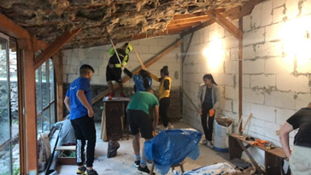
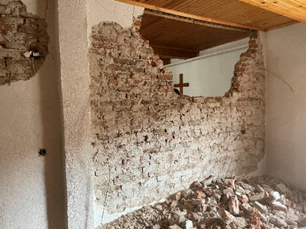
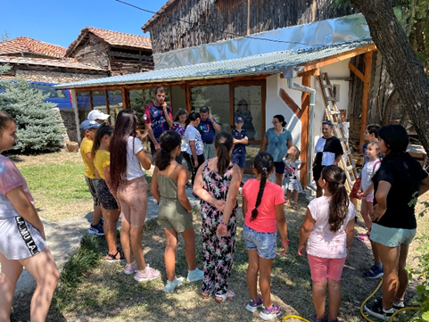

By the grace of God, regular services are held in the ECC in the village of Garvanovo. In the church besides me some of the guest preachers were Rev. Bunardjiev, brothers Emanuil Petrov and Ivaylo Stoilov.
During the last six months, two children were baptized and a wedding was held. The Lord's Supper is served regularly. After the services I conducted, there were talks to clarify the doctrines. Sister Vasilka, who cannot attend services, was regularly visited. During the summer we held a training event for children.
Rev. Nikolay Valchev - ECC - Garvanovo

The Evangelical Congregational church in city of Plovdiv continues to pray diligently and work on its project to plant a new church in the West district, where there is no other evangelical church. For one year, a small group gathered in a room rented for the purpose. Brochures for Christmas and Easter were distributed. Some people from other churches were coming. We are joyful for the new young family that comes regularly.
At ECC Plovdiv we had a Christmas concert on December 18. We are joyful for the new young people and three new families in the church, two of whom have joined as members. Roof repairs remain a challenge. We can't find a company that is committed to this complex project. We need another 25 000,- euros to be able to do it.
Rev. Ivan Stoitsev - ECC - Plovdiv

We built a small wooden house containing Christian literature to spread the gospel and placed it at the entrance of the church.
Our activity continues as a mother church in the city of Ruse, as Rev. Emanuil Tinev and families from the church visit and take care of the community there every month.
Luko Shindarov - ECC - Panagyurishte

In the last six months, we have completed our sermon series on the First Epistle to Timothy and started a new series about the Sermon on the Mount. We did a seminar for unmarried people in our church. The children of the Vladimir and Gergana Marinovi family accepted water baptism. Finally, we began a new internship in our church that aims to train a person to become a pastor.
Vlado Hristov - ECC - Mladost, Sofia

In recent years, God has led us to work with Roma men to build and train leaders equipping them in Biblical literacy. The number of Roma churches in Bulgaria is constantly growing, but unfortunately they are not sound in teaching. So far we have trained 3 different groups. Despite the difficulties associated with the COVID19 pandemic, we managed to continue and the graduation of the last class is in a few days. The enrollment of students for the next 4th round is coming soon. We have a training center in the village of Lenovo near Plovdiv. Due to the increased interest in education, in recent months we have focused on creating a second training center in southeastern Bulgaria, where there is a large concentration of Roma population.
We believe that this is a very important and God-pleasing work. We need your prayerful support.
Rev. Delcho Atanasov - ECC - Parvomay and ECC - Trakia

The church in Asenovgrad managed to build a shed in the backyard, which will be used for fellowship of believers and for events for children ministry. We have participated in several projects for distributing brochures among our fellow citizens. In the end of 2021, alongside with the preparation of various programs for the holidays, we was mobilized to reach 60 indigene families by providing them with food, a Christian book and the New Testament.
Rev. Georgi Zhelev

